Michael S. Haupert, D.O. | Prasad J. Thottam, D.O. | Colin T. Bohr, D.O.
Lindsay A. Ruwart, FNP-C | Deena R. Garmo, NP-C | Abigayle L. Alger, PNP-AC

Clinton Township | West Bloomfield
42645 Garfield, Suite 109 | 7001 Orchard Lake Road, Suite 320C
Clinton Township, MI 48038 | West Bloomfield, MI 48322
248-571-3600 | 248-571-3600
Fax 586-416-1712 | Fax 248-973-8560

Dear Patient family,

Welcome to Michigan Pediatric Ear, Nose, & Throat Associates!

Our doctors and support staff are dedicated to making sure your experience in our office is one that you will be pleased with.

To help us ensure that your first visit goes smoothly, please take a few minutes to fill out the registration and history forms completely. It is very important that the parent accompanies the child to the first office visit so that an accurate medical history can be obtained and the doctor can explain the plan of care at the time of visit.

It is of the utmost importance that you arrive at your scheduled appointment time to complete the registration process; any tardiness on your part will delay your appointment.

Lastly, please remember to bring the following with you to your appointment:

- Picture ID-Birth Parent or Legal Guardian
- Insurance Cards-ALL insurance cards must be presented to ensure proper billing
- Insurance Co-Pay-ALL co-payments required by your insurance company each time you visit the office for any service. Payment is always expected at the time of service and will be collected when you check in for your appointment.
- Insurance Referral-If you have Blue Care Network, HAP HMO through Henry Ford, Tri-Care Prime or Health+, you will need to get a referral from your PCP for your office visit. If you do not have a referral, your appointment will need to be rescheduled.
- Test Results-If you have any reports or results that would help the doctor with your office visit, please make sure to bring a copy for review at your appointment.
- Proof of Guardianship-If you have a foster child or are not the birth parent of the child, please bring a note from the birth parent or your guardianship papers

If you are unable to make your scheduled appointment, please give the office a call as soon as possible

Failure to show up for a scheduled appointment will result in a No Show fee of $25

If you need to cancel or reschedule your appointment, please call (248) 571-3600.

If you require a translator for your visit, please contact the office prior to your appointment.
Thank You
See You Soon!

MICHIGAN PEDIATRIC ENT
PATIENT REGISTRATION FORM

PHARMACY : _________________________________________________ PHONE:__________________________
(NAME & LOCATION)

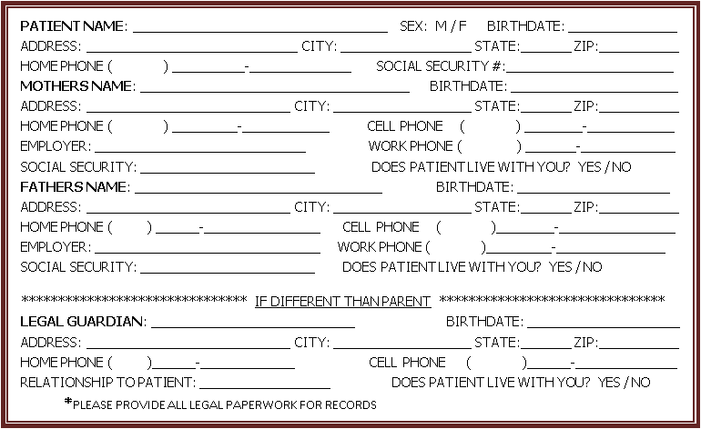

**PLEASE GIVE THE RECEPTIONIST YOUR INSURANCE CARD(S) AND PHOTO ID TO COPY. THANK YOU **

I authorize the release of any information pertinent to my case to any insurance company which is necessary to process my medical claims for any service rendered. I permit a copy of this authorization to be used in place of the original. I understand I am responsible for any changes not covered by my insurance company. I also permit the release of information to my primary care physician or a physician MPENTA may refer my child to for follow up.

_________________________________________________ Date: _________________________
Signature of Parent / Guardian

HEALTH HISTORY QUESTIONNAIRE

Name |  |  |  |  |  |  |  |  |  |  |  |  |  |  |  |  |  |  | M F
Date of Birth |  |  |  |  |  |  |  | Social Security Number

Email
Language |  |  | Arabic |  | English |  |  |  | Spanish |  |  |  | Other |  |  |  |  | Decline to Answer
Do you need and interpreter? |  |  |  |  |  |  | Yes |  |  |  | No
Ethnicity |  |  | Arab Decent |  | Hispanic/Latino |  |  |  | Other |  |  |  | Unknown |  |  |  |  | Decline to Answer
Race | African American |  |  |  |  | American Indian |  |  |  |  |  | Asian |  |  |  |  | Caucasian
 | Native American |  |  |  |  | Other |  |  |  |  |  | Unknown |  |  |  |  | Decline to Answer

Pharmacy | Phone

PCP/Pediatrician | Phone

PREVIOUS STUDIES
Has your child had any previous studies done? |  |  |  | Blood Work |  | Bone Scan |  | CT Scan
EMG | MRI |  | Sleep Study |  | Ultrasound |  | X Ray |  | Other

Where did you have testing done?

Have you traveled outside of the US in the past 3 weeks? | Yes | No

Reason for visit today?
When did you first notice this problem? | 2 days ago | 2 weeks ago | 1 month ago | >1 month

ALLERGIES
Allergic To | Reaction
No Known Allergies (PLEASE CHECK IF NONE)

Medications

List your prescribed drugs and over-the-counter drugs, such as vitamins and inhalers
Name the Drug | Strength | Frequency Taken
Not currently taking any Medications (PLEASE CHECK IF NONE)

PERSONAL HEALTH HISTORY

Check ALL Conditions that apply to your child (current and past)

Frequent Ear Infections (H66.90) | Cleft Lip (Q36.9) | Blurred Vision (H53.8)
Hearing Loss (H91.90) | Cleft Palate (Q35.9) | Change in Vision (H53.9)
Ringing in Ears (H93.19)
Popping in Ears (H93.89X) | Sickle Cell Anemia (D57.1) | Heart Murmur (R01.1)
 | Bruising Easily (R23.8) | Irregular Heartbeat (I49.9)
Dizziness (R42) | Blood Clotting Problems (D68.9) | High Blood Pressure (I10)
Fainting (R55)
Seizure Disorder (G40.909) | Throat Infections (J02.9) | Sleep Apnea (G47.30)
 | Hoarseness (R49.0) | Poor Sleep Quality (G47.9)
Speech Delay (F80.9) | Frequent Clearing Throat (R68.89) | Gasping (R06.89)
 | Wheezing (J45.909) | Irritable (R45.4)
Sinus Disorders (R09.89) | Asthma (J45.909) | Insomnia (G47.00)
Nose Bleeds (R04.0) | Swollen Glands (R59.9) | Snoring (R06.83)
Congestion (R09.81) | Persistent Cough (R05)
Sneezing (R06.7) |  | Jaundice (R17)
Environmental Allergies (Z91.09) | Failure to Thrive (R62.51)
Facial Pain (R51.9) | Stridor (R06.1) | Diabetes (E11.9)
Dental Pain (K08.89) | GERD (K21.9) | Thyroid Disease (E07.9)
 | Poor Eating Habits (E63.9)
Meningitis (G03.9) | Spitting Up-Infant (R11.10) | Headache (R51.9)
 | Upper Lip Tie (Q38.0) | Migraine (G43.909)
Autism (F84.0) | Tongue Tie (Q38.1)
 |  | Other _______________

past surgical history
Surgery | Date | Hospital
Tubes
Tonsillectomy
Adenoidectomy

social HISTORY
Who does your child live with? | Mom | Dad | Step-Mom |  | Step-Dad | Other
Does anyone smoke in the child’s home? |  | Yes | No | Outside
Are immunizations up to date? |  | Yes | No
Do you use seatbelts? |  | Yes | No

Birth history
Weight at Birth
Did child pass Newborn Hearing Screening? |  |  |  |  |  |  | Yes |  | No
Was child born premature? |  |  | No | Yes |  |  |  | Gestational Age: ____weeks _____days  Days in NICU? ____days
What feeding method did you use at birth? |  |  |  |  | - Breast Fed |  |  |  |  | - Bottle Fed Breast Milk |  |  | - Bottle Fed Formula
Birth Delivery Method: |  | - Vaginal |  |  |  | - Cesarean Section |  |  |  |  | - Other:

Are there any other concerns that you would like to discuss with the Doctor at your visit today?
 | Signature | Relationship to Patient | Date

INSURANCE REFERRALS AND AUTHORIZATIONS

OFFICE VISIT

If you have any of the following insurances, an authorization number MUST be obtained from your Primary Care Physician (PCP) for an office visit prior to being seen in the office

**If you do not have your referral at the time of your appointment you will be asked to reschedule**

- Blue Care Network (Blue Elect Plus - Exempt)
- United Healthcare (select plans)
- HAP (Henry Ford Network Only)
- TriCare (Prime)
- Community Care Associates (only valid for 1 visit, a new referral must be obtained EACH visit)

Please have your PCP office fax the global referral to:

West Bloomfield 248-973-8560 Clinton Township 586-416-1712

It is the patients responsibility to obtain the referral/authorization

Advance Beneficiary Notice of Noncoverage (ABN)
Patient Name: |  | Date of Birth:

Note: Some insurance plans do not cover audiology testing that you or your health care provider have good reason to recommend. If your insurance does not pay for the audiology services rendered, you will be responsible for any out-of-pocket costs.
- | 92557 | $110 | Comprehensive Audiometry | - | 92567 | $45 | Tympanometry
- | 92556 | $85 | Speech Audiometry with Speech Recognition | - | 92555 | $55 | Speech Audiometry
- | 92552 | $69 | Pure Tone Audiometry | - | 92579 | $125 | VRA
- | 92587 | $50 | Distortion Product Evoked Otoacoustic Emissions

WHAT YOU NEED TO DO NOW:
- Read this notice, so you can make an informed decision about your care.

- Ask us any questions that you may have after you finish reading.

- The doctor WILL NOT perform all listed services, only tests that are deemed NECESSARY.
  - The doctor typically recommends audiology testing for any ear-related concerns.

- Choose an option below:
If recommended, I WANT the Audiology Services listed above. I understand that
If my insurance does not pay, I am responsible for any fees not covered.

I DO NOT WANT the Audiology Services listed above.

Signing below means that you have received and understand this notice:

Signature: |  |  | Date:
Relationship to Patient:

Michael S. Haupert, DO | Prasad J. Thottam DO | Colin. T. Bohr, DO
Lindsay A. Ruwart, FNP-C | Deena R. Garmo, NP-C | Abigayle L. Alger, PNP-AC
Lena Jamal, AUD | Rachel Prange, AUD | Elizabeth A. Mandell, AUD

9/22 SM

